**Admin Login**

**Admin Home page contains 8 modules. They are**

**1. Admission**

**2. Post Exam**

**3. DC Bills**

**4. Academic**

**5. Assessment**

**6. Pre-Examination**

**7. Results**

**8. Settings**

**9. Student Services**

**10. TWSH**

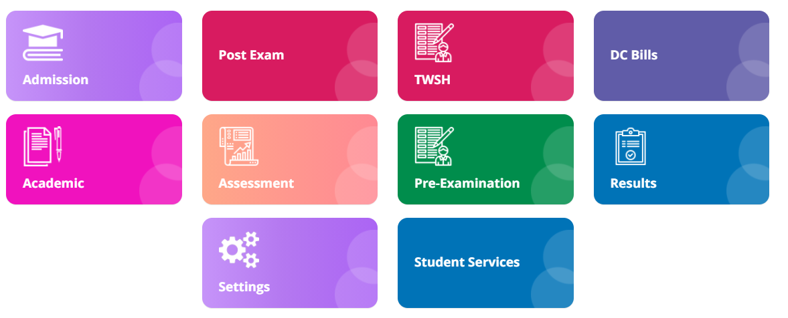

**Module Name: Pre-Examination**

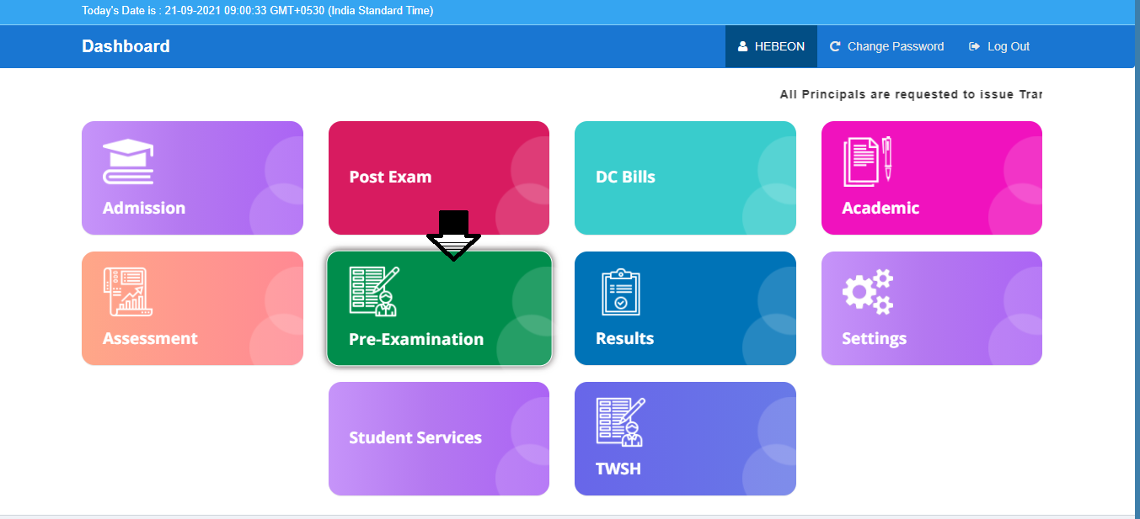  
**Module Description:**

**Pre-Examination** module consists sub-modules namely **Set exam month year, Set exam centers, Fee payment, Fee eligible reports, NR session report, Printer NR download.**

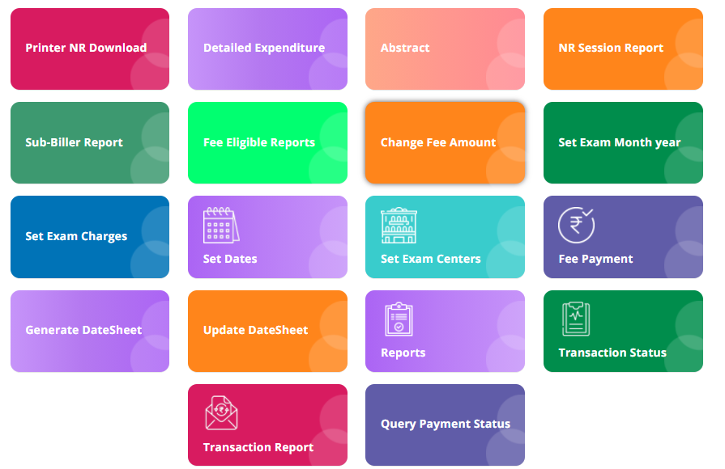

**1) Sub module name: Set exam month year**

**Description:**

This sub module is used to set the exam month year for examination

**Navigation steps**

**Step1: Open set exam month year**

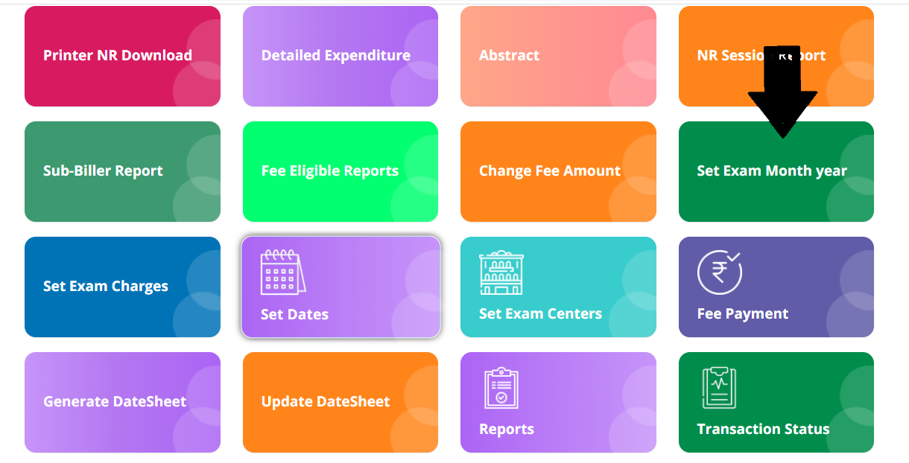

**Step2: Add the month and year then click on Add**

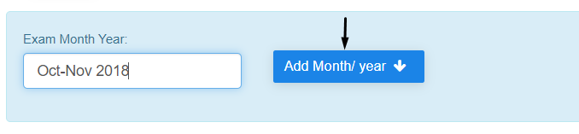

**Step3: To edit /update the exam month and sequence use EDIT button**

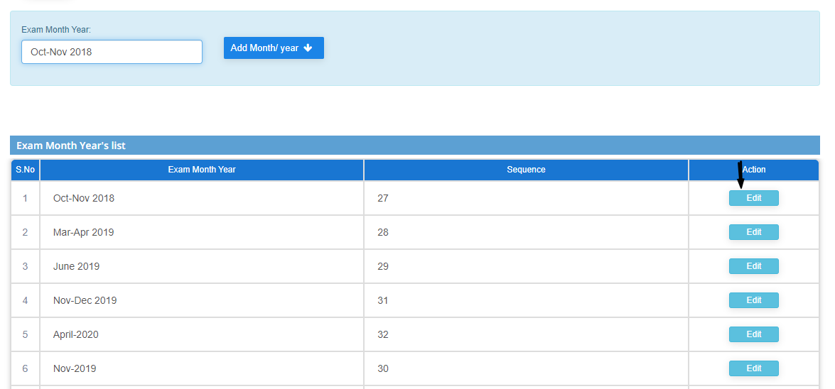

**2) Sub module name: Set examination centers**

**Description:**

This sub module is used to set the exam center for a student

**Navigation steps**

**Step1: Open set examination centers**

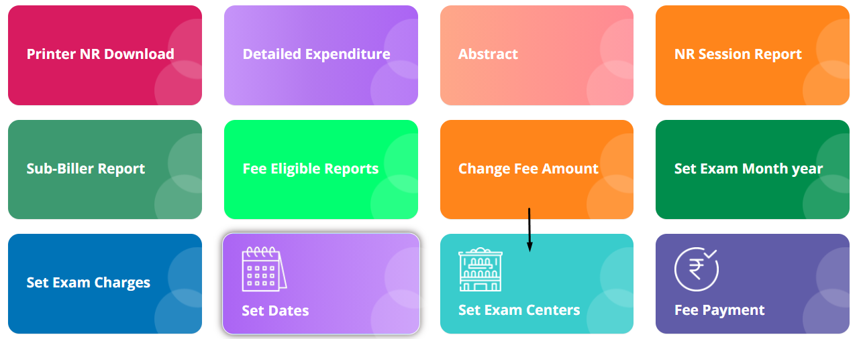

**Step2: Select exam type and year**

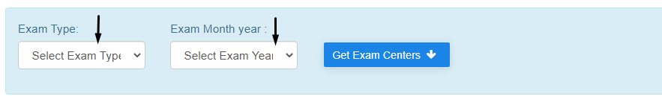

**Step3: After selecting the fields click on Get Exam Centers. You will get the list of centers for the given data which is shown below.**

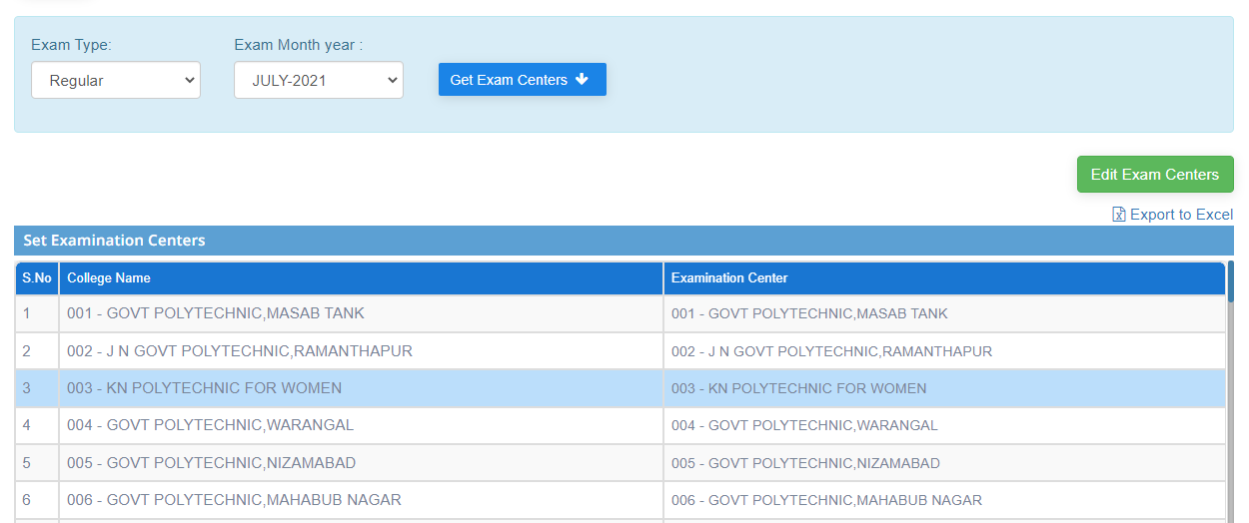

**Step4: If any changes are to be done, use Edit Exam centers**

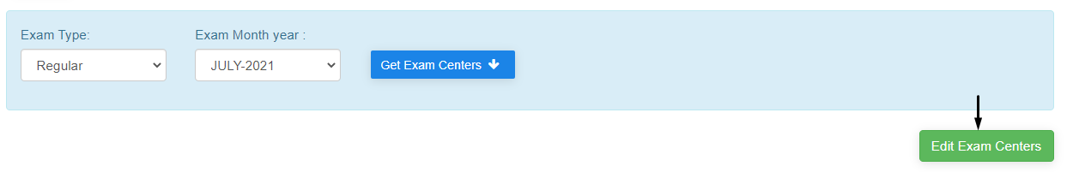

**Information:**  
To get bulk details, click on the Export to excel (which is below the Edit button). Excel will be downloaded.

**3) Sub module name: Set dates**

**Description:**

This sub module is used to set the exam date for a student

**Navigation steps**

**Step1: Open set dates**

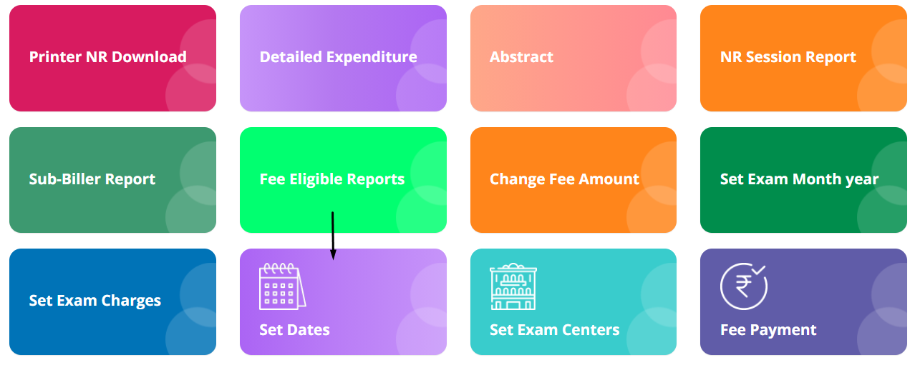

**Step2: Click on Upload COE signatures to upload digital signatures. The second image demonstrates to upload the file and update the signature.**

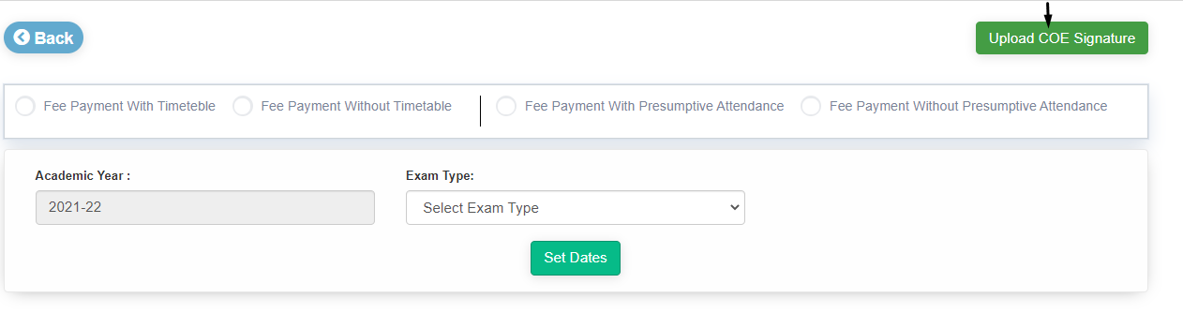

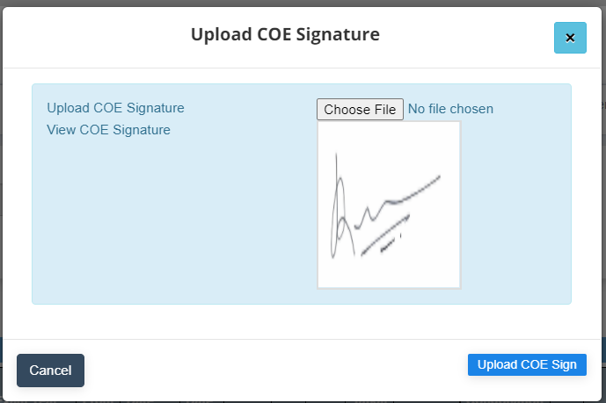

**Step3:** After uploading the signature, we need to select Academic year and exam type that displays to fill in the details of the exam

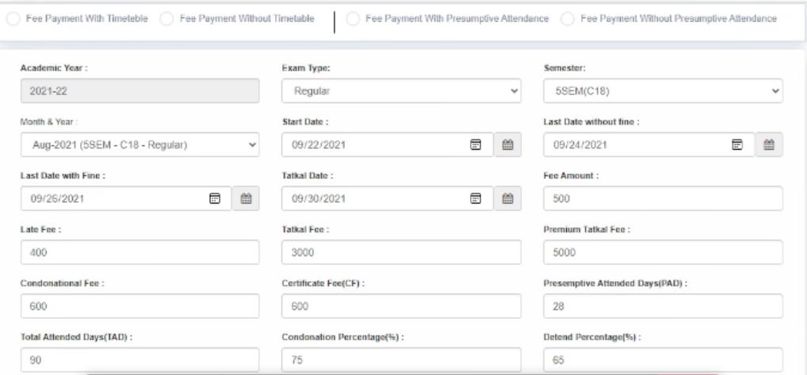

* Here there are 4 scenarios to get the dates. They are:   
   **fee payment with timetable**  
  **fee payment without a timetable**  
  **fee payment with Presumptive Attendance**  
  **fee payment without Presumptive Attendance**
* If any of the above scenarios are not selected then by default it will be selected as **fee payment with timetable** and **fee payment with Presumptive Attendance**
* The **Late Fee determines** the fee payment after the last date of examination.
* The **Tatkal Fee determines** the fee payment which can be paid before few days of examination
* **Premium Tatkal fee determines** the fee payment which can be paid on the day of examination.

**4) Sub module name: Fee Payment**

**Description:**

This sub module is used to pay the exam fee for a particular monthly/year

**Navigation steps**

**Step1: Open fee payment**

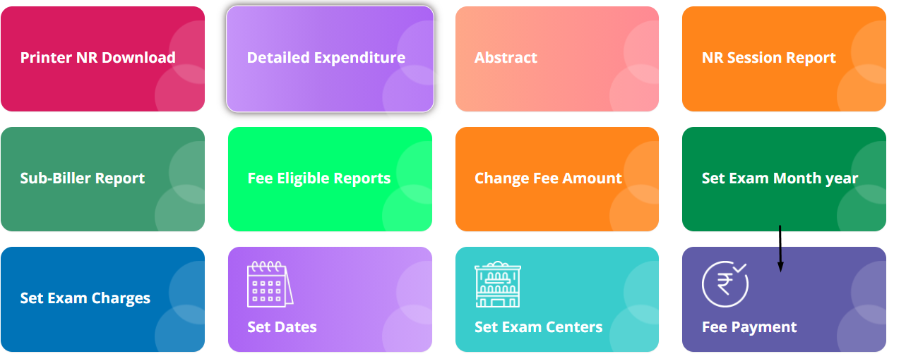

**Step2: Fill the given details:**

1. **Fee type**
2. **Exam month year**
3. **Pin number**
4. **Captcha**

**Step2.1: After filing the details click on Get details**

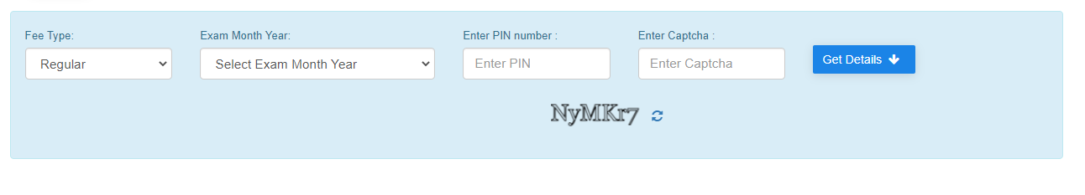

**Step3: The details of student who paid fee amount is shown below**

**Step4: Payment confirmation is to be done by verifying details**

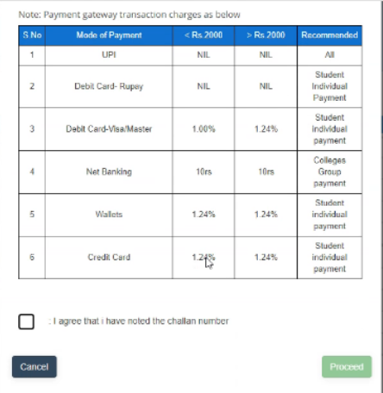

**Step5: After confirming the details clink on checkbox given in the end of the dialog box. Then click on proceed.**

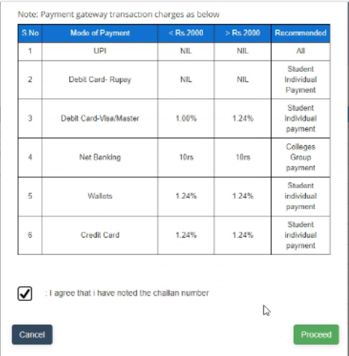

**Step6: The payment gateway is show in the below image**

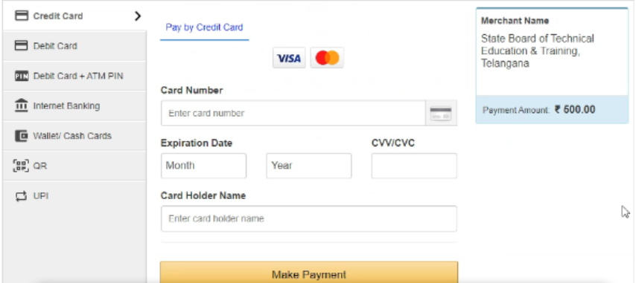

**5) Sub module name: NR Session Report**

**Description:**

This sub module is used to get session report by center wise

**Navigation steps**

**Step1: Open NR Session Report**

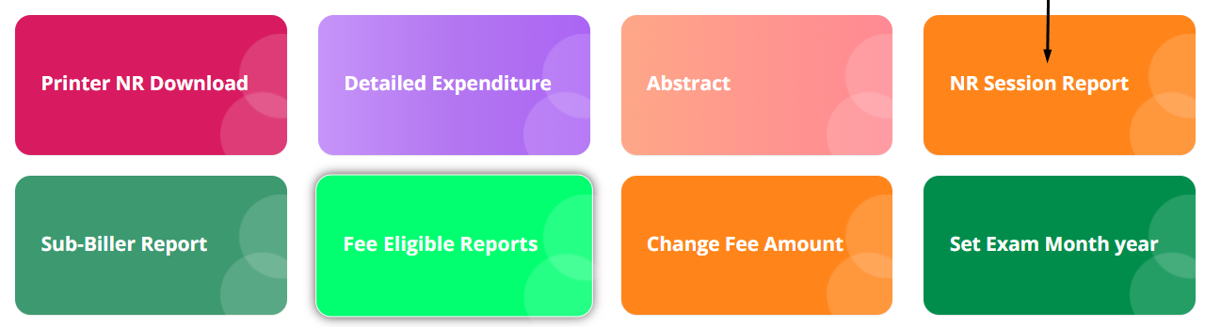

**Step2: Fill the academic year, student type, exam month/year fields from dropdown to get the report.**

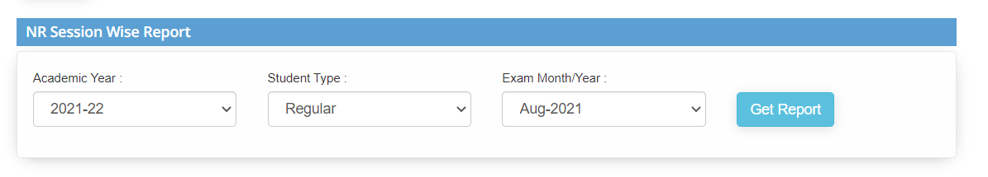

**Step3: After selecting the details from the dropdown click on Get Report.**

**Then the session report is displayed.**

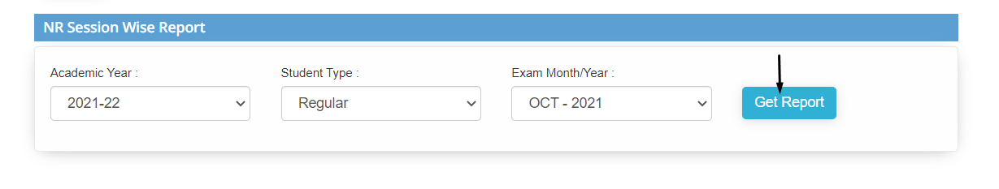

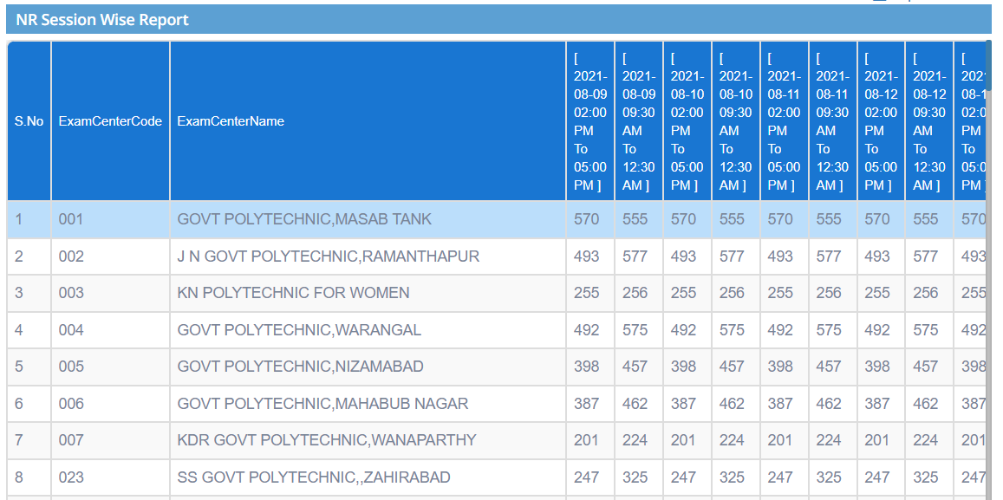

**Information:**  
The report can be downloaded by clicking on **Export to Excel** (which is above the report). The downloaded file is shown as:

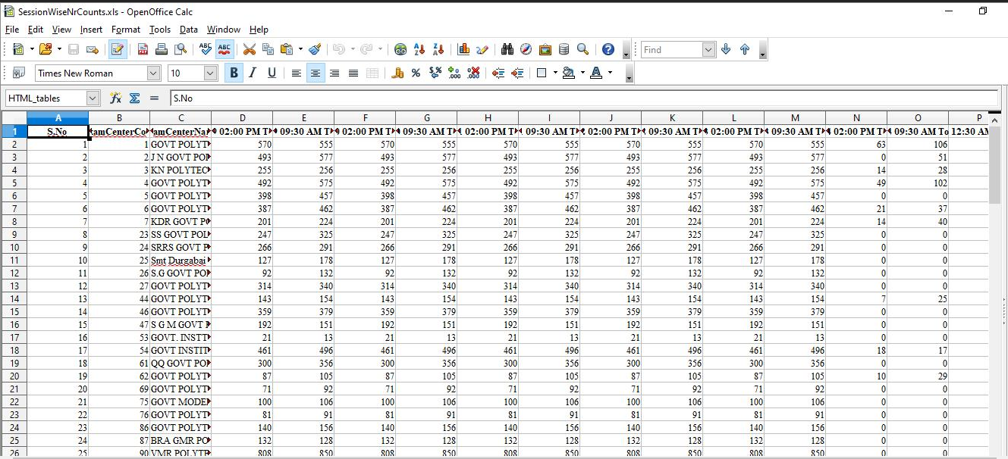

**6) Sub module name: Printer NR Download**

**Description:**

This sub module is used to download the NR session reports

**Navigation steps**

**Step1: Open Printer NR Download**

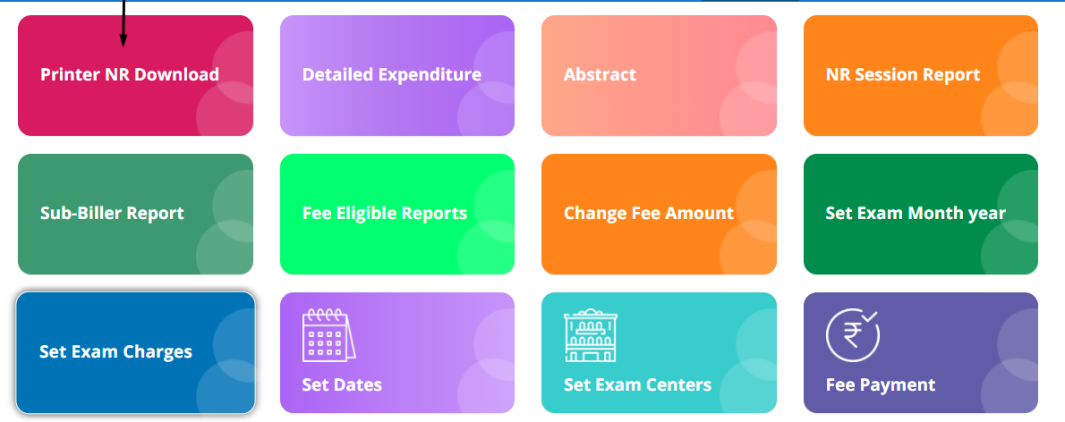

**Step2: Fill the details from the dropdown in each field.**   
**You can download the NR report and Branch report in excel form**

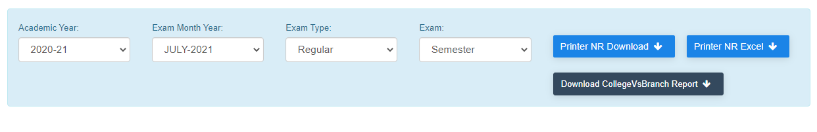

**7) Sub module name: Fee eligible Report**

**Description:**

This sub module is used to get the report of the students who are eligible to pay the exam fees

**Navigation steps**

**Step1: Open Fee eligible Report**

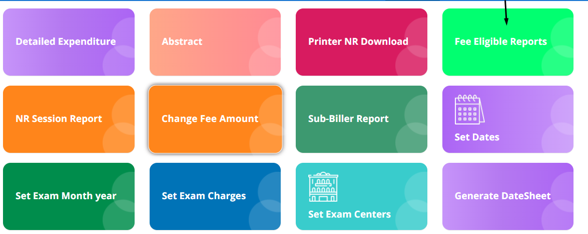

**Step2: Select the exam month/year and student type from the dropdown list**

**Click on Get Report. Excel file will be downloaded**

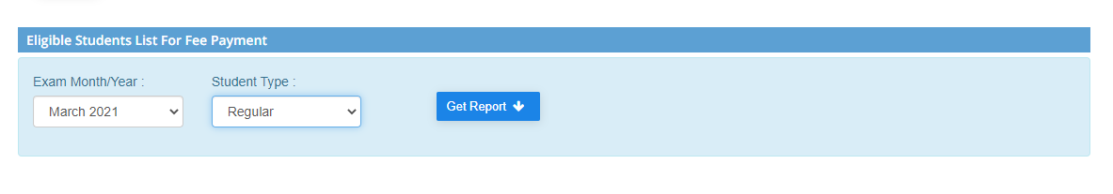

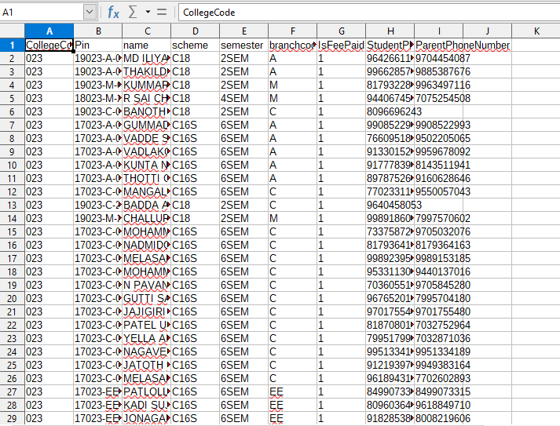

**8) Sub module name: Change fee amount**

**Description:**

This sub module is used to change the fee amount for an exam

**Navigation steps**

**Step1: Open Change fee amount**

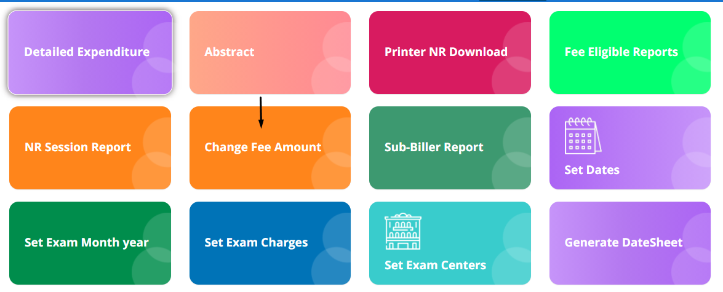

**Step2: Fill up exam the details and appropriate fee amount that should be updated**

**Click on Enable fee payment**  
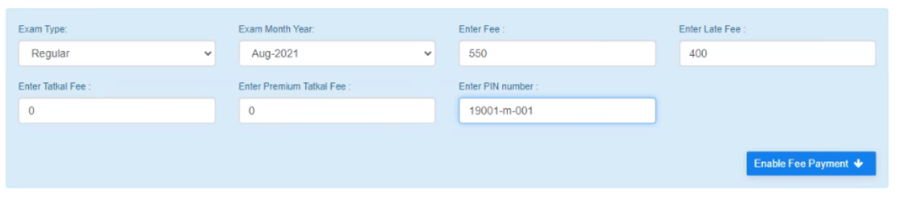

**9) Sub module name: Sub-Biller Reports**

**Description:**

This sub module is used to get the fee payment reports

**Navigation steps**

**Step1: Open Sub-Biller Reports**

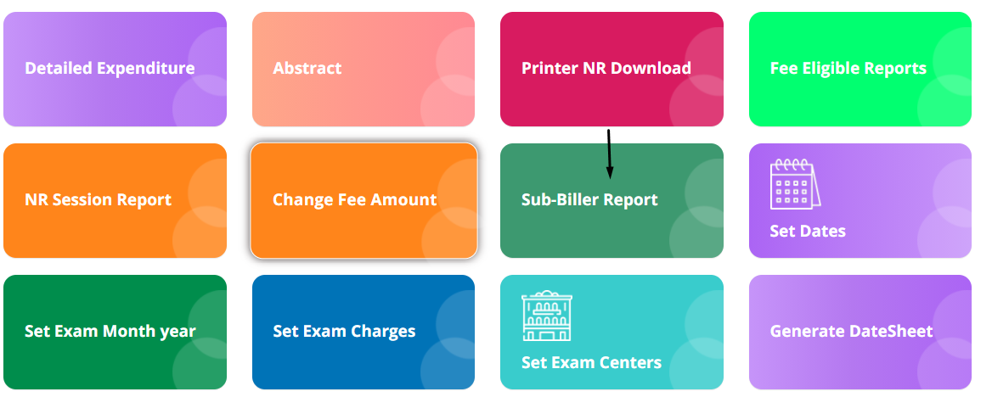

**Step2: Enter the biller id, from and end date and click on Get Report**

**Excel file will be downloaded**

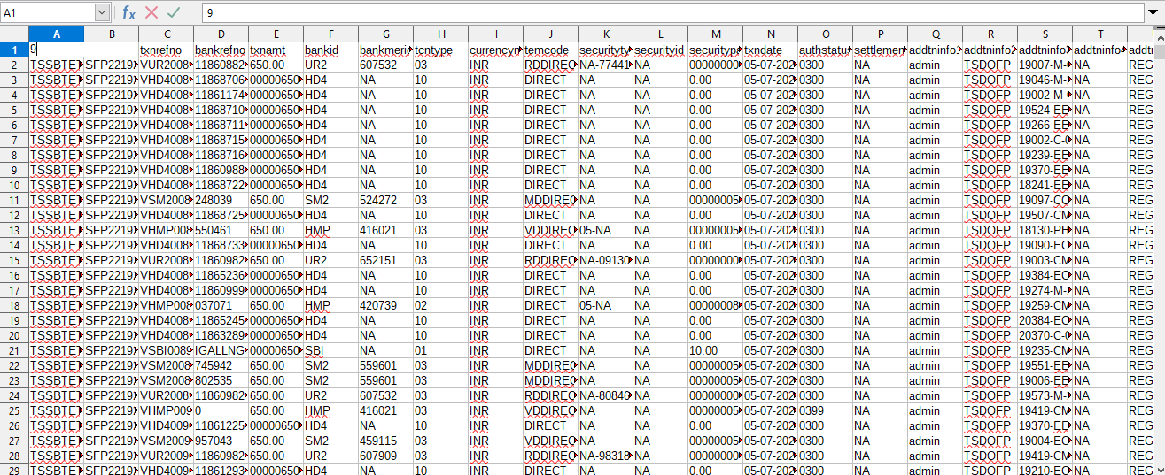

**10) Sub module name: Generate datesheet**

**Description:**

This sub module is used to prepare timetable

**Navigation steps**

**Step1: Open Set exam charges**

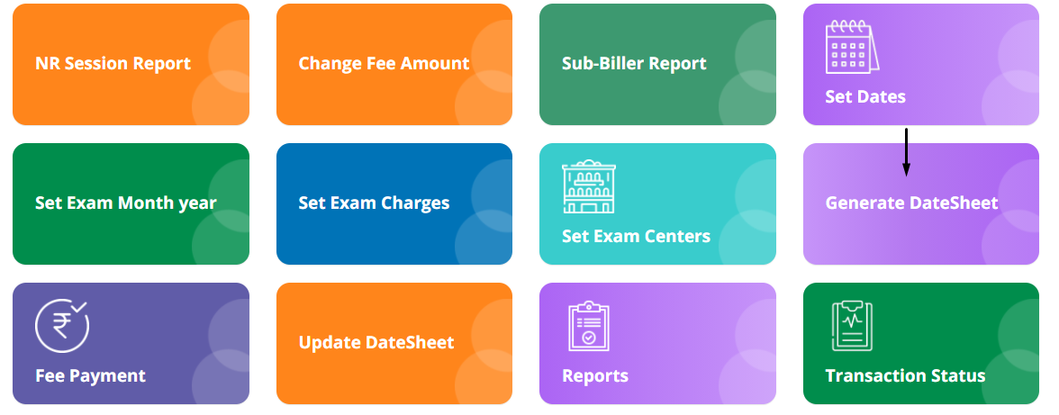

**Step2: Fill up all the mandatory details**

**Note:**  
**C18 Subjects/Tantalized Subjects is only for backlog students**

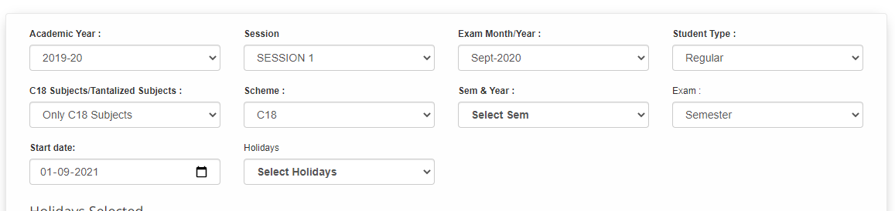

**Step3: Holidays option is to give the gaps in timetable to prepare for next exams or if any festival arrives**

**Selected holidays will be listed below**

**Click on Set and Generate Date sheet**

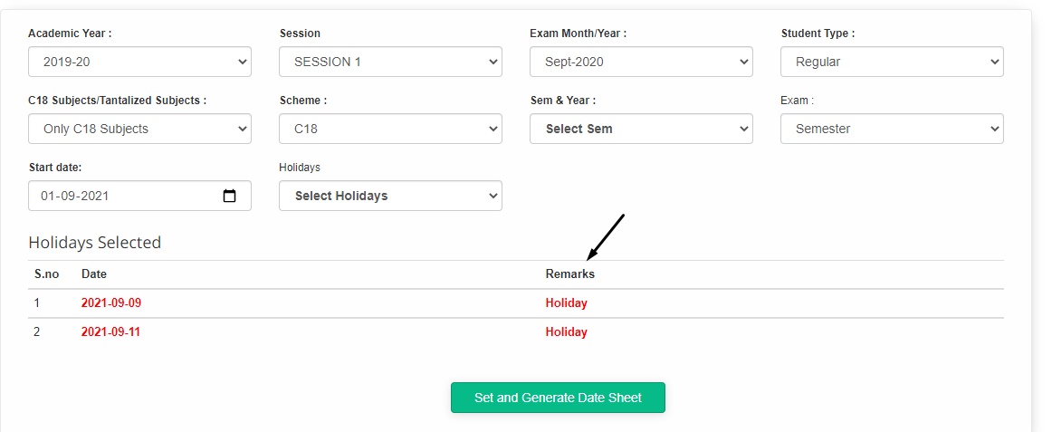

**11) Sub module name: Update Datesheet**

**Description:**

This sub module is used to update the generated timetable

**Navigation steps**

**Step1: Open Update Datesheet**

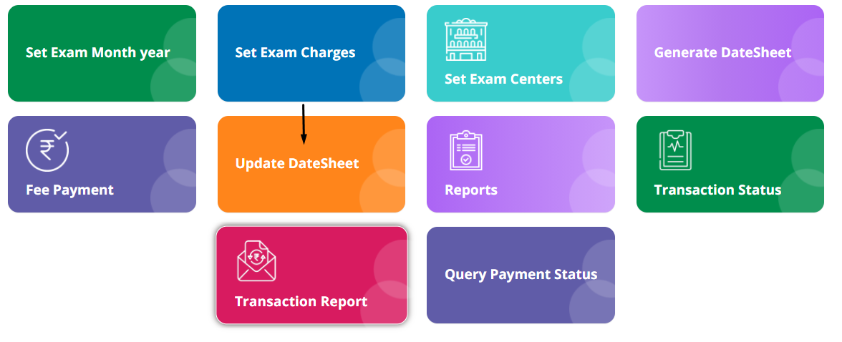

**Step2: There are 3 criterias to update the timetable**  
**1. Branch wise timetable**  
 **Fill up the mandatory details and click on Get data**

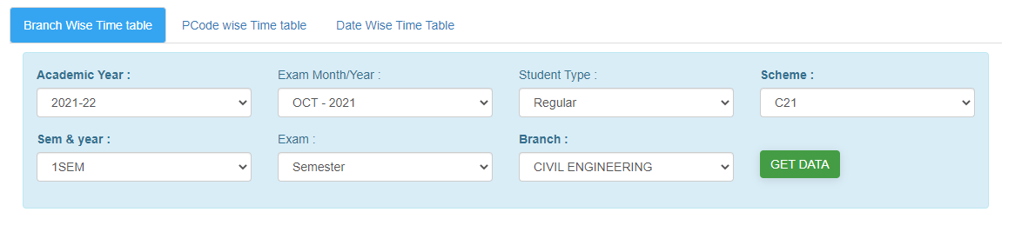

**The data will be displayed**

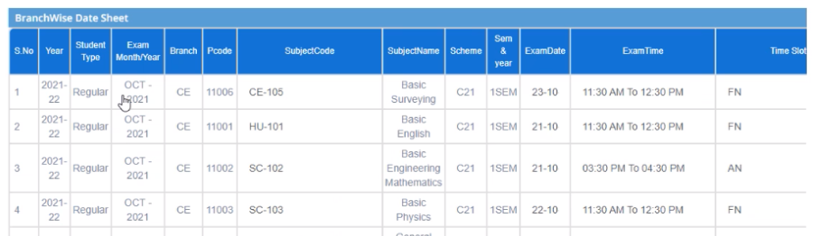

**To and update the data click on edit**

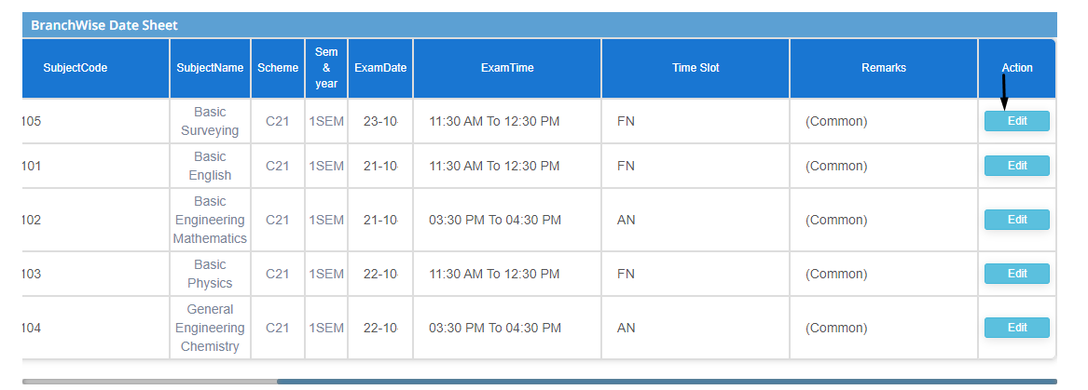

**To download the updated data, select the same details as given to update the timetable**  
**Download the file in by clicking on any export formats(pdf,excel,edep)**

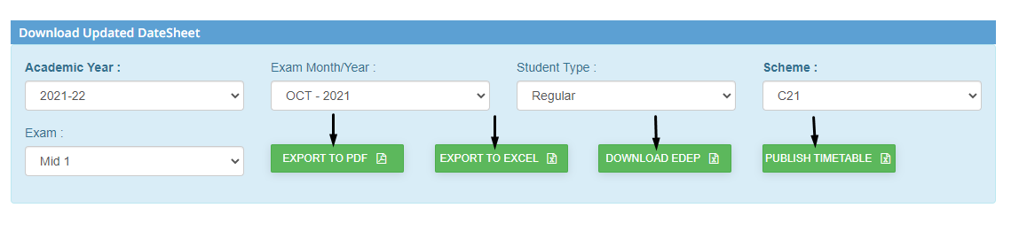

**2. Pcode wise timetable**  
 **Fill up the mandatory details and click on Get data**

**Note:**  
**Pcode can be retrieved from branch wise timetable report**

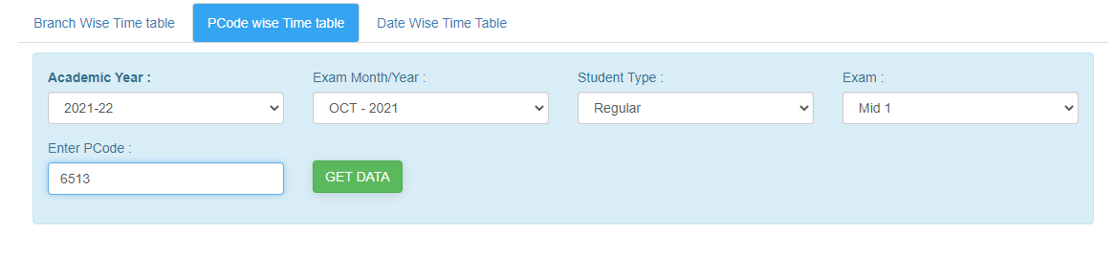

**The data will be displayed**

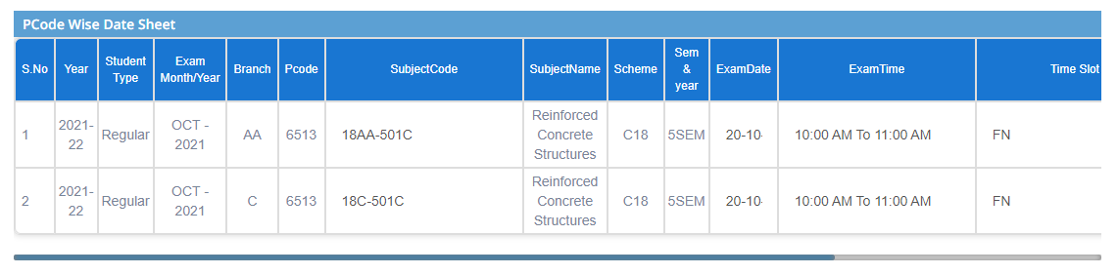

**To and update the data click on edit**

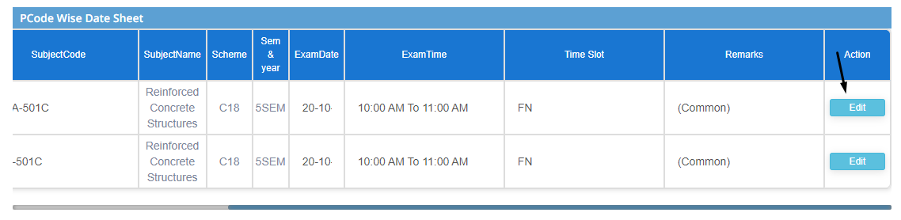

**To download the updated data, select the same details as given to update the timetable**  
**Download the file in by clicking on any export formats(pdf,excel,edep)**



**3. Date wise timetable**  
 **Fill up the mandatory details and click on Get data**

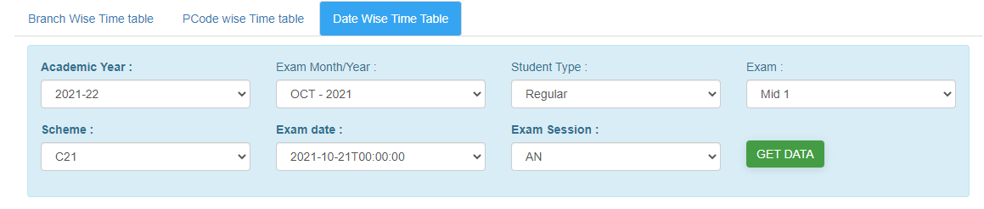

**The data will be displayed**

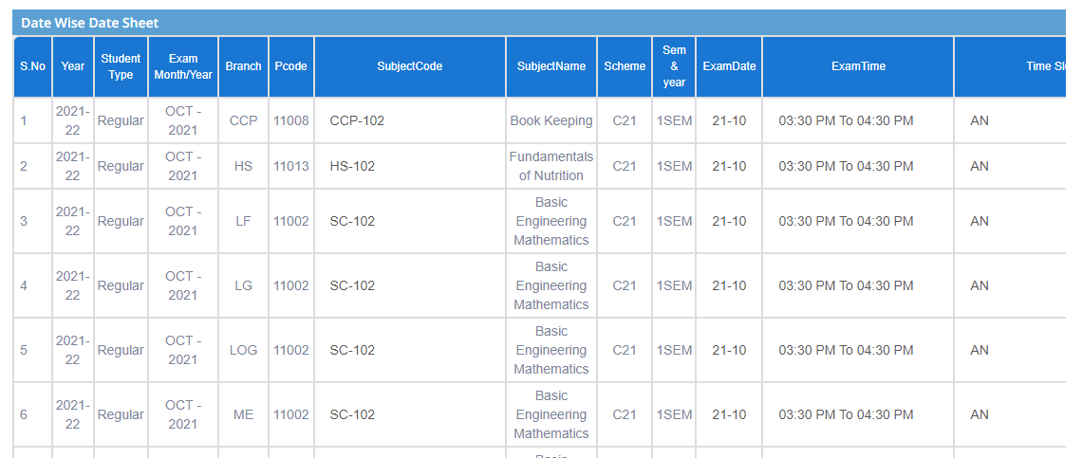

**To and update the data click on edit**

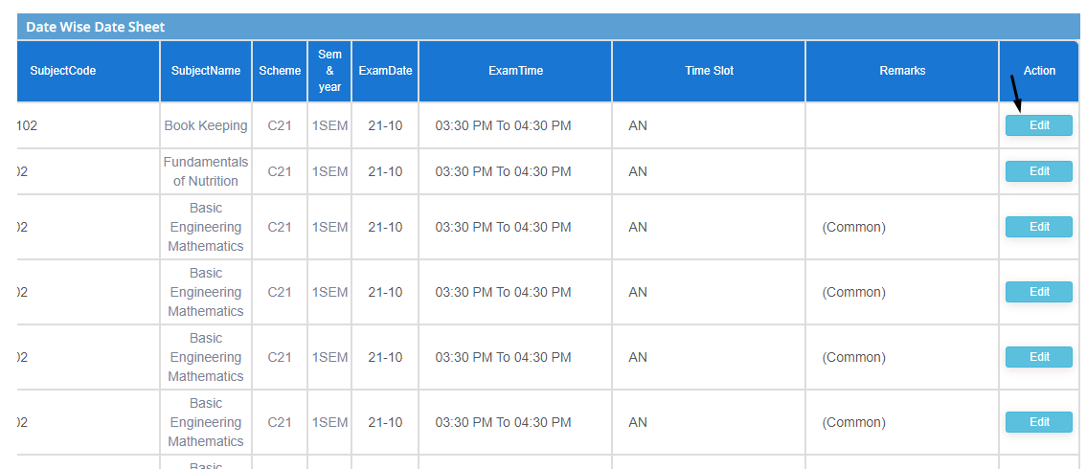

**To download the updated data, select the same details as given to update the timetable**  
**Download the file in by clicking on any export formats(pdf,excel,edep)**



**12) Sub module name: Transaction status**

**Description:**

This sub module is used to retrieve the transactional status of paid fees

**Navigation steps**

**Step1: Open Transaction status**

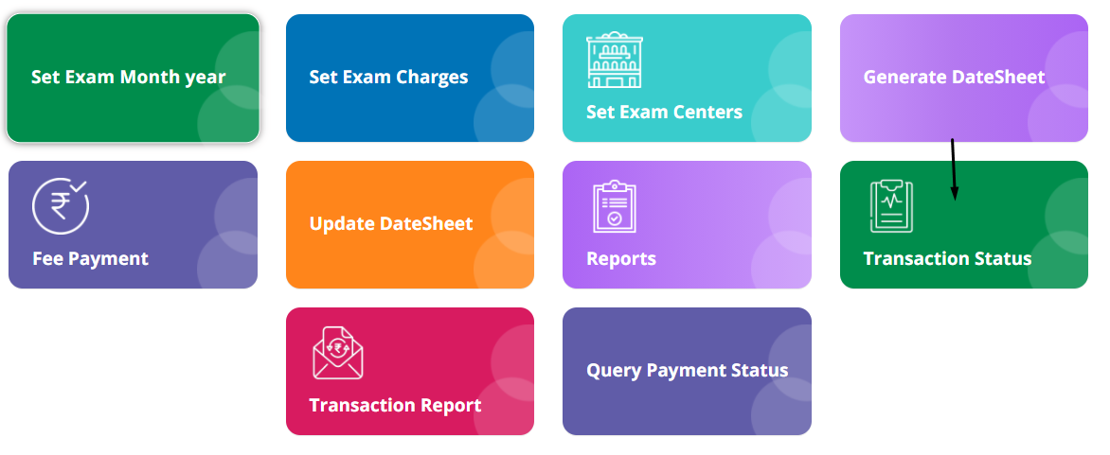

**Step2: Enter the exam type and generated challan number when fees were paid**

**Click on Get details**

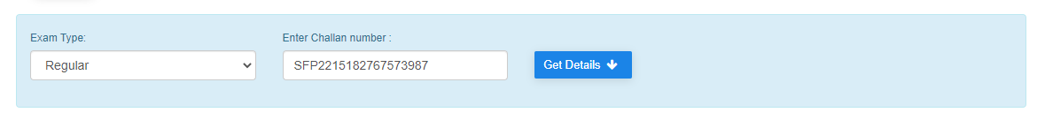

**Step3: The payment summary will be displayed**

**You can even print the receipt by clicking on Print**

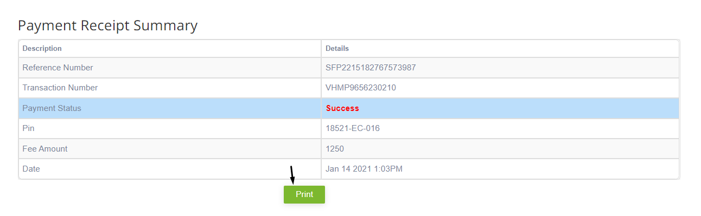

**13) Sub module name: Query payment status**

**Description:**

This sub module is used to retrieve the complete status of paid fees

**Navigation steps**

**Step1: Open Query payment status**

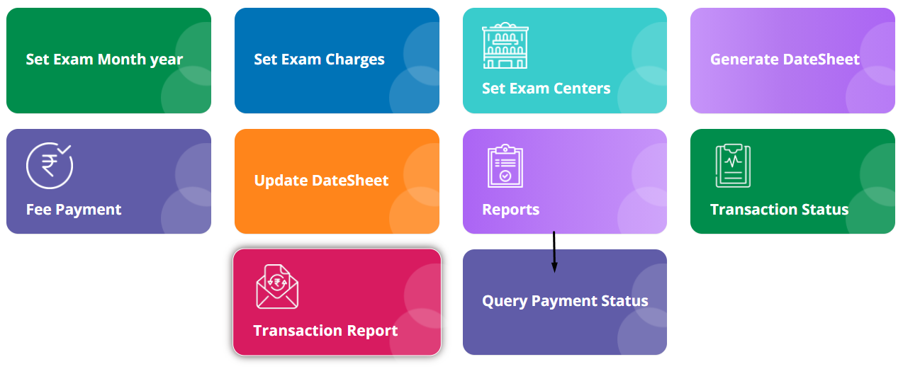

**Step2: Enter the generated challan number when fees were paid**

**Click on Get details**

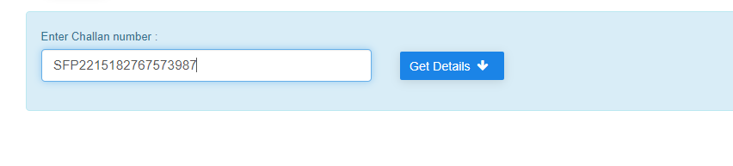

**Step3: The payment summary will be displayed**

**You can even print the receipt by clicking on Print**

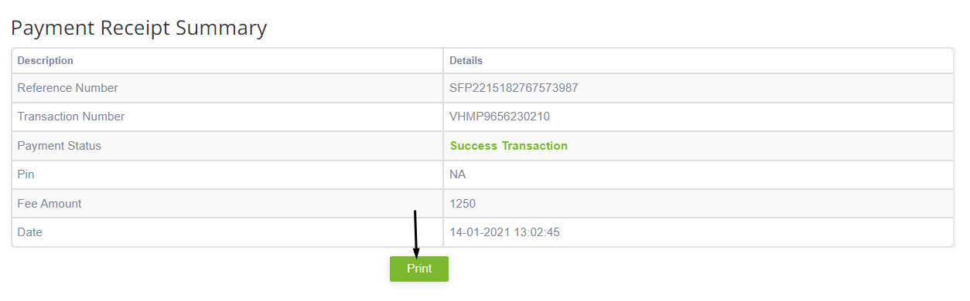

**14) Sub module name: Reports**

**Description:**

This sub module is used to get the fee payment reports

**Navigation steps**

**Step1: Open Reports**

**Step2: Enter the exam month year and semester**   
**Click on Get fee payment report**  
**The report will be displayed**

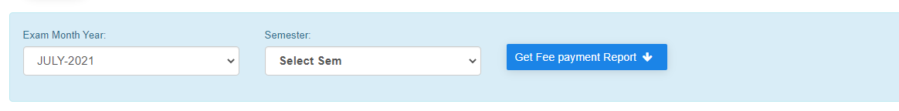

**15) Sub module name: Transaction Report**

**Description:**

This sub-module is used to get the successful and not successful fee transaction report

**Navigation steps**

**Step1: Open Transaction Report**

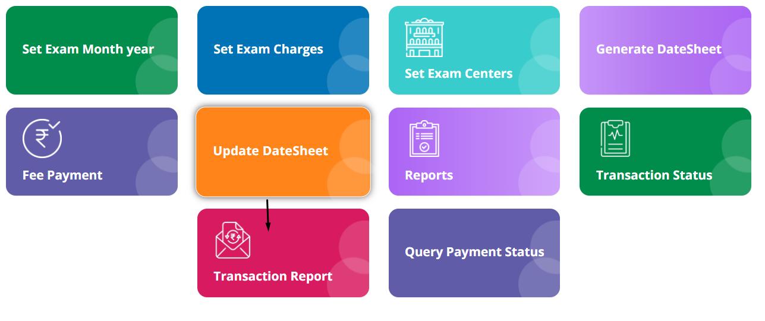

**Step2: Fill the mandatory details**  
**Enter start and end date**  
**Click on Get details**

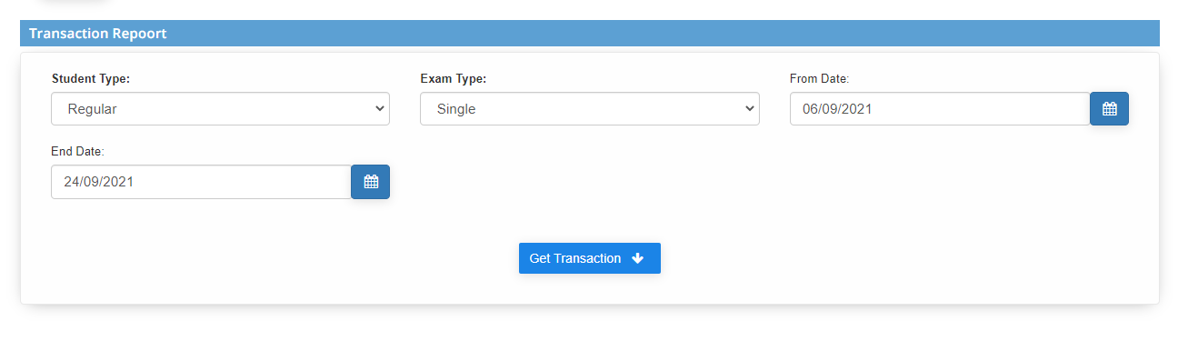

**Step3: The details will be displayed for particular given dates**